***Potential uses for Audacity in your classroom***

* Recording feedback to students on essays or projects (an alternative to written feedback)
* Record lectures for absent students
* Create podcasts which recap the information of the previous week or provide extensions, giving students additional interesting, related information to your subject matter
* Allow students to create podcasts in lieu of or in addition to writing an essay or report to demonstrate their knowledge

***Getting Started***

You will find Audacity in the “My Applications” folder on your desktop. Open it and double-click on Audacity to open the program. **As with anything, it’s a good idea to save and save often.** Go to File/Save As before you start recording to create an Audacity project file and save often as you work.

***Basic Controls***

****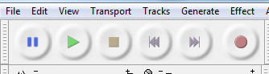

***Pause Play Stop Rewind Fast Record***

***Foward***

When you are ready to record audio, simply hit the red “record” button. You can use the “pause” button if you want to take a break in the middle and then simply hit the pause button again to continue.

When you are finished recording, hit the square “Stop” button. On your screen, you will see your first “track” that will look something like this:

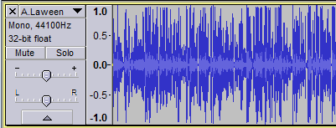

Try using the triangular “Play” button to listen to what you’ve just recorded.

***Adding to your audio track***

If you want to continue adding more to what you’ve just recorded, you simply need to press “record” again. You will notice that Audacity will automatically record this into a new track for you, so your screen will look something like this:

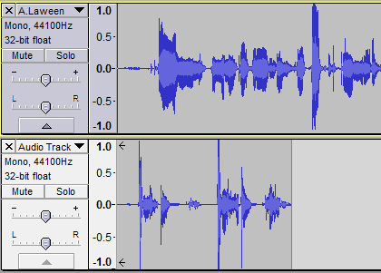

Continue recording until you have all of the audio you want to use (we’ll discuss editing in a moment).

**Note:** I recommend recording multiple, shorter tracks rather than trying to get everything perfect in one long take. That way, if there is something you want to edit out, the process is easy and if you need to re-record a section, you won’t have to start from scratch.

***Editing***

Once you have your tracks recorded, you’ll need to place them in order and edit them. There are several ways to do this, but you will need to know a few tricks:

tools.PNGAt the top of Audacity, you’ll find these tool buttons. The default tool is called the **selection tool** and is located on the top left. You can use this to highlight sections of your audio, just like you would highlight words in a document. **You can use this tool to highlight and delete** sections of audio you don’t want to use or cut and paste, just like you would in Word. You can also use it to select where to start your playback when listening to tracks you’ve recorded so you don’t have to listen from the beginning each time.

The only other tool you’ll really need is the **Time shift tool**, located in the center of the bottom row. **This tool allows you to move your tracks left and right so that you can line them up to play in order**. If you leave them stacked on top of one another, as my example above shows, the two tracks will play at the same time. This is useful if you want to play music at the same time as voice audio, for example, but most of the time, you only want one track to play at a time.

If in the example above, I wanted the second track I recorded to be my introduction, I’d **select the** **time shift tool**, then **select the first track by left-clicking and dragging the entire track to the right** until Audacity indicates by means of a yellow line that the two tracks have lined up and are not overlapping.

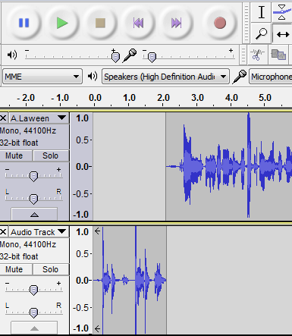

***Select time shift tool***

***Click on and drag the track until it lines up, as indicated by the yellow line***

**zoom.PNGTip:**  If you are working with a large number of tracks or tracks of long length, try zooming out to make it easier to see what you’re doing. You can select the tool on the far right to place your entire project in view.

***Finalizing your product***

When you have listened to all of your audio, lined up your tracks, and are satisfied with your recording, it’s time to export your product. You’ve been saving your work as an Audacity project file, which means you can edit your work easily. However, others cannot easily listen to your work in this format.

Go to file🡪export as MP3

You will have several pop-up windows that allow you to set things such as ‘genre’ of music and artist name. (Audacity assumes you’re recording music.) This is entirely optional to complete. You can always just click “ok” and Audacity will save your file as an mp3 without problem. Once your file has been converted, you can then easily share your work with anyone.

**One last note:** Don’t be surprised if the quality of the audio drops slightly upon conversion to mp3; this is an unfortunate side effect of the conversion process.